**Calculating Gravity**

**Objective:** The purpose of this experiment is to have you determine the acceleration due to gravity accurately using an inclined plane.

# **Equipment**

* A track.
* Toy cart.
* Two Photo gates.
* Something to incline the aluminum track (i.e. books, boxes).
* Computer to connect the photo gates.
* Meter stick.

# **Procedure**

1. Prepare the timer by connecting the photo gates to the computer.
2. Prepare the track. Carefully set the track horizontal. Then place a spacer under one of the track's legs to raise one end of the track and write down the height.
3. Let the cart roll down a distance X by starting from some position Xo and record

T1: time for the tab on the cart to pass through the first photogate)   
T2: time between the start of t1 and the start of t3

T3: time for the tab on the cart to pass through the second photogate.   
Repeat 4 times from the same Xo.

1. Calculate V1 and V3 with respect to the Length of Tab and T1 or T3 (i.e. V1= Length of Tab / T1 and V3 = Length of Tab / T3).
2. 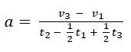Calculate the acceleration for the runs with the formula
3. Take the average and standard deviation of the accelerations that you got.
4. Repeat steps 2 – 6 four more times, each time by changing the Height.
5. Once done, change the weight of the cart and repeat steps 2-7.
6. Create one (X, Y) Scatter graph with the average accelerations and height got from the lightweight cart and another for the heavy cart.
7. Add a trendline to the graphs and show its function.
8. Get the gravity for lightweight cart and the heavy cart.

**Data**

|  |  |
| --- | --- |
| **Lightweight Cart on an Incline** | |
| Total Mass (g): | 416.3 |
| Length of Tab (cm): | 11 |

|  |  |  |  |  |  |  |
| --- | --- | --- | --- | --- | --- | --- |
| **Trial 1** | height (cm): | 3.0 |  |  |  |  |
|  |  |  |  |  |  |  |
|  | t1 (s) | t2 (s) | t3 (s) | v1 (cm/s) | v3 (cm/s) | a (cm/s2) |
| run 1: | 0.2700 | 0.9975 | 0.1681 | 40.7 | 65.4 | 26.1 |
| run 2: | 0.2865 | 1.0443 | 0.1729 | 38.4 | 63.6 | 25.5 |
| run 3: | 0.2826 | 1.0287 | 0.1706 | 38.9 | 64.5 | 26.3 |
| run 4: | 0.2647 | 0.9862 | 0.1674 | 41.6 | 65.7 | 25.8 |
|  |  |  |  |  |  |  |
|  |  |  | average acceleration (cm/s2): | | | 25.9 |
|  |  |  |  | stdev (cm/s2): | | 0.3 |
|  |  |  |  |  |  |  |
| **Trial 2** | height (cm): | 5.0 |  |  |  |  |
|  |  |  |  |  |  |  |
|  | t1 (s) | t2 (s) | t3 (s) | v1 (cm/s) | v3 (cm/s) | a (cm/s2) |
| run 1: | 0.2023 | 0.7526 | 0.1258 | 54.4 | 87.4 | 46.3 |
| run 2: | 0.2088 | 0.7682 | 0.1271 | 52.7 | 86.5 | 46.6 |
| run 3: | 0.2103 | 0.7724 | 0.1274 | 52.3 | 86.3 | 46.6 |
| run 4: | 0.2018 | 0.7512 | 0.1259 | 54.5 | 87.4 | 46.1 |
|  |  |  |  |  |  |  |
|  |  |  | average acceleration (cm/s2): | | | 46.4 |
|  |  |  |  | stdev (cm/s2): | | 0.2 |
|  |  |  |  |  |  |  |
| **Trial 3** | height (cm): | 6.9 |  |  |  |  |
|  |  |  |  |  |  |  |
|  | t1 (s) | t2 (s) | t3 (s) | v1 (cm/s) | v3 (cm/s) | a (cm/s2) |
| run 1: | 0.1773 | 0.6413 | 0.1079 | 62.0 | 101.9 | 65.8 |
| run 2: | 0.1709 | 0.6247 | 0.1063 | 64.4 | 103.5 | 66.0 |
| run 3: | 0.1775 | 0.6423 | 0.1077 | 62.0 | 102.1 | 66.1 |
| run 4: | 0.1784 | 0.6430 | 0.1079 | 61.7 | 101.9 | 66.3 |
|  |  |  |  |  |  |  |
|  |  |  | average acceleration (cm/s2): | | | 66.1 |
|  |  |  |  |  | stdev (cm/s2): | 0.2 |
|  |  |  |  |  |  |  |
| **Trial 4** | height (cm): | 9 |  |  |  |  |
|  |  |  |  |  |  |  |
|  | t1 (s) | t2 (s) | t3 (s) | v1 (cm/s) | v3 (cm/s) | a (cm/s2) |
| run 1: | 0.1543 | 0.5603 | 0.0949 | 71.3 | 115.9 | 84.1 |
| run 2: | 0.1535 | 0.5578 | 0.0945 | 71.7 | 116.4 | 84.7 |
| run 3: | 0.1553 | 0.5632 | 0.0949 | 70.8 | 115.9 | 84.6 |
| run 4: | 0.1617 | 0.5784 | 0.0965 | 68.0 | 114.0 | 84.2 |
|  |  |  |  |  |  |  |
|  |  |  | average acceleration (cm/s2): | | | 84.4 |
|  |  |  |  | stdev (cm/s2): | | 0.3 |
|  |  |  |  |  |  |  |
| **Trial 5** | height (cm): | 10.8 |  |  |  |  |
|  |  |  |  |  |  |  |
|  | t1 (s) | t2 (s) | t3 (s) | v1 (cm/s) | v3 (cm/s) | a (cm/s2) |
| run 1: | 0.1443 | 0.5198 | 0.0864 | 76.2 | 127.3 | 104.1 |
| run 2: | 0.1424 | 0.5145 | 0.0859 | 77.2 | 128.1 | 104.5 |
| run 3: | 0.1518 | 0.5369 | 0.0880 | 72.5 | 125.0 | 104.0 |
| run 4: | 0.1457 | 0.5229 | 0.0865 | 75.5 | 127.2 | 104.7 |
|  |  |  |  |  |  |  |
|  |  |  | average acceleration (cm/s2): | | | 104.3 |
|  |  |  |  | stdev (cm/s2): | | 0.3 |

|  |  |  |
| --- | --- | --- |
|  | **Lightweight Cart on an Incline** |  |
|  | height (cm) | a (cm/s2) |
| Trial 1: | 3.0 | 25.9 |
| Trial 2: | 5.0 | 46.4 |
| Trial 3: | 6.9 | 66.1 |
| Trial 4: | 9.0 | 84.4 |
| Trial 5: | 10.8 | 104.3 |

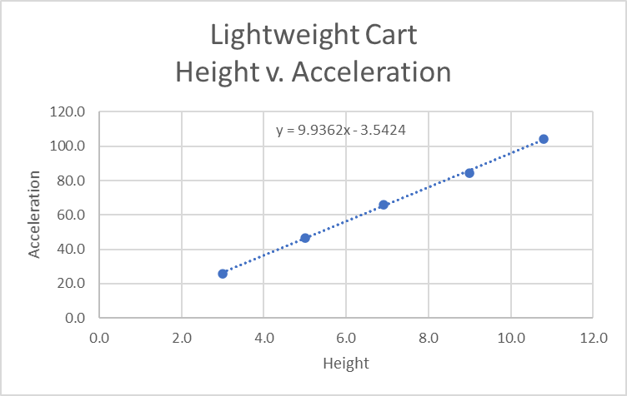

|  |  |
| --- | --- |
| **Heavy Cart on an Incline** | |
| Total Mass (g): | 920.3 |
| Length of Tab (cm): | 11 |
|  |  |

|  |  |  |  |  |  |  |
| --- | --- | --- | --- | --- | --- | --- |
| **Trial 1** | height (cm): | 3.0 |  |  |  |  |
|  |  |  |  |  |  |  |
|  | t1 (s) | t2 (s) | t3 (s) | v1 (cm/s) | v3 (cm/s) | a (cm/s2) |
| run 1: | 0.2753 | 1.0162 | 0.1718 | 40.0 | 64.0 | 25.0 |
| run 2: | 0.2813 | 1.0265 | 0.1702 | 39.1 | 64.6 | 26.3 |
| run 3: | 0.2911 | 1.0713 | 0.1799 | 37.8 | 61.1 | 23.0 |
| run 4: | 0.2729 | 1.0070 | 0.1692 | 40.3 | 65.0 | 25.9 |
|  |  |  |  |  |  |  |
|  |  |  | average acceleration (cm/s2): | | | 25.0 |
|  |  |  |  | stdev (cm/s2): | | 1.5 |
|  |  |  |  |  |  |  |
| **Trial 2** | height (cm): | 5.0 |  |  |  |  |
|  |  |  |  |  |  |  |
|  | t1 (s) | t2 (s) | t3 (s) | v1 (cm/s) | v3 (cm/s) | a (cm/s2) |
| run 1: | 0.2050 | 0.7569 | 0.1258 | 53.7 | 87.4 | 47.1 |
| run 2: | 0.2052 | 0.7567 | 0.1256 | 53.6 | 87.6 | 47.4 |
| run 3: | 0.2142 | 0.7817 | 0.1286 | 51.4 | 85.5 | 46.3 |
| run 4: | 0.2067 | 0.7613 | 0.1262 | 53.2 | 87.2 | 47.1 |
|  |  |  |  |  |  |  |
|  |  |  | average acceleration (cm/s2): | | | 47.0 |
|  |  |  |  | stdev (cm/s2): | | 0.5 |
|  |  |  |  |  |  |  |
| **Trial 3** | height (cm): | 6.9 |  |  |  |  |
|  |  |  |  |  |  |  |
|  | t1 (s) | t2 (s) | t3 (s) | v1 (cm/s) | v3 (cm/s) | a (cm/s2) |
| run 1: | 0.1710 | 0.6244 | 0.1059 | 64.3 | 103.9 | 66.8 |
| run 2: | 0.1746 | 0.6333 | 0.1069 | 63.0 | 102.9 | 66.6 |
| run 3: | 0.1690 | 0.6191 | 0.1054 | 65.1 | 104.4 | 66.9 |
| run 4: | 0.1736 | 0.6299 | 0.1062 | 63.4 | 103.6 | 67.5 |
|  |  |  |  |  |  |  |
|  |  |  | average acceleration (cm/s2): | | | 66.9 |
|  |  |  |  | stdev (cm/s2): | | 0.4 |
|  |  |  |  |  |  |  |
| **Trial 4** | height (cm): | 9 |  |  |  |  |
|  |  |  |  |  |  |  |
|  | t1 (s) | t2 (s) | t3 (s) | v1 (cm/s) | v3 (cm/s) | a (cm/s2) |
| run 1: | 0.1545 | 0.5598 | 0.0944 | 71.2 | 116.5 | 85.6 |
| run 2: | 0.1572 | 0.5665 | 0.0950 | 70.0 | 115.8 | 85.6 |
| run 3: | 0.1580 | 0.5689 | 0.0953 | 69.6 | 115.4 | 85.2 |
| run 4: | 0.1554 | 0.5611 | 0.0947 | 70.8 | 116.2 | 85.5 |
|  |  |  |  |  |  |  |
|  |  |  | average acceleration (cm/s2): | | | 85.5 |
|  |  |  |  | stdev (cm/s2): | | 0.2 |
|  |  |  |  |  |  |  |
| **Trial 5** | height (cm): | 10.8 |  |  |  |  |
|  |  |  |  |  |  |  |
|  | t1 (s) | t2 (s) | t3 (s) | v1 (cm/s) | v3 (cm/s) | a (cm/s2) |
| run 1: | 0.1431 | 0.5159 | 0.0858 | 76.9 | 128.2 | 105.4 |
| run 2: | 0.1490 | 0.5302 | 0.0873 | 73.8 | 126.0 | 104.5 |
| run 3: | 0.1448 | 0.5196 | 0.0863 | 76.0 | 127.5 | 105.0 |
| run 4: | 0.1467 | 0.5244 | 0.0868 | 75.0 | 126.7 | 104.7 |
|  |  |  |  |  |  |  |
|  |  |  | average acceleration (cm/s2): | | | 104.9 |
|  |  |  |  | stdev (cm/s2): | | 0.4 |

|  |  |  |
| --- | --- | --- |
|  | **Heavy Cart on an Incline** |  |
|  | height (cm) | a (cm/s2) |
| Trial 1: | 3.0 | 25.0 |
| Trial 2: | 5.0 | 47.0 |
| Trial 3: | 6.9 | 66.9 |
| Trial 4: | 9.0 | 85.5 |
| Trial 5: | 10.8 | 104.9 |

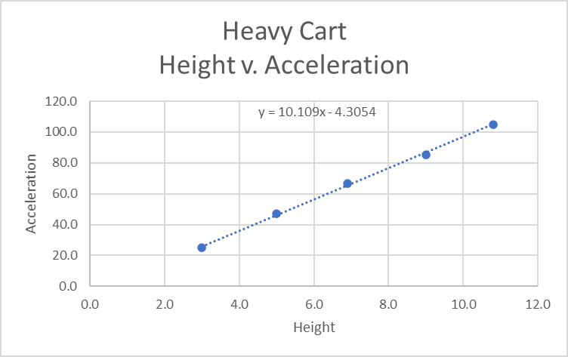

**Results:**

|  |  |
| --- | --- |
| "g" for lightweight cart (m/s2): | 9.9 |
| "g" for heavy cart (m/s2): | 10.1 |

Find the trial that shows a much higher standard deviation than the others. Why is the standard deviation much higher? What could have caused this?

* The cart that created much higher deviation is the heavy cart. Some of the reasons that could have caused this are user interference (i.e. pushing the cart) or machine error (i.e. computer having lag and creating a delay when recording time).

What was the one variable measured that was never used? What does this tell you about the acceleration due to gravity?

* One variable that was never used is the distance traveled in the x direction. This makes sense since gravity is pulling down not to the side.

The uncertainty in the slope works out to be about 0.50 m/s2. What does this uncertainty tell us about the data and the procedure used to collect it? What would it take to narrow the uncertainty?

* The uncertainty tells us that there might be other components that are affecting the answer. For example:  
  - the measurement of lengths with a meter stick.

- the intrinsic measurement accuracy of acceleration with the computer program.

- the influence of air resistance on the cart.

Within uncertainty, do the values between the lightweight cart and the heavy cart agree? Should this be the case?

* Yes, according to Newtonian theory, this value should be the same for all objects regardless of mass.

**Conclusion**

The best estimate we have found for the value of g is 9.9 ± 0.5 m/s. Our result for the two different glider masses shows that g is independent of mass and are consistent within their 0.50 m/s2 uncertainty. The average value of g from the two masses is 10.00 ± 0.5. Our results are consistent with the value given. There are several sources of uncertainty in the determination of the gravitational acceleration: 1) the measurement of lengths with a meter stick; 2) the intrinsic measurement accuracy of acceleration with the computer program; and 3) the influence of air resistance on the glider. The measurement of the length between the air track supports is appropriate for the meter stick since the length to be measured is comparable to stick length and the fractional error is small. However, using the same stick to measure the small height of the blocks used for inclination leads to a much larger fractional error. These lengths would be better measured using calipers or a micrometer. The uncertainty in the height accounts for essentially all of the uncertainty on the determination of the inclination angle. Since the angle stays fixed for several trial measurements of the acceleration, this error does not play a role in determining the spread of acceleration values. The uncertainty in the determination of acceleration accounts for essentially all of the spread in our values of g. This spread is presumably partially due to actual small differences between the trials and partially to limitations in the instruments and software. Fitting various parts of a section of good data and repeating this for several data plots indicate that we have 0.50 m/s2 uncertainty in our acceleration measurements, which leads to the 0.50 m/s2 spread in our determination of g for a fixed incline angle. Some method for directly determining velocity, e.g. with direct timing measurements over short intervals might reduce this uncertainty. Finally, air resistance needs to be reduced. Air resistance gives us lower values of acceleration than we would otherwise measure, hence it should tend to push our measured values of g lower than the true value. It is difficult to measure the extent of this effect. We see little evidence for it in our measurements, presumably because air resistance increases as the speed of the glider increases and all our velocities for small inclination angles are small.